Ex. No. : 03 Date:
Register No : 231701007 Name: BADRISH RS

A python program to implement logistic model.

Aim:
To implement the Logistic Model (Logistic Regression) using Python.

Requirements:
Jupyter Notebook with Python.

PROGRAM:
# Logistic Model Implementation
import numpy as np
import matplotlib.pyplot as plt
x = np.array([0, 1, 2, 3, 4, 5])
y = np.array([0, 0, 0, 1, 1, 1])
b0 = -2 # Intercept
b1 = 1 # Slope
def sigmoid(z):
return 1 / (1 + np.exp(-z))
z = b0 + b1 * x
y_pred = sigmoid(z)

print("Predicted Probabilities:")
print(y_pred)
# Plot graph
plt.scatter(x, y)
plt.plot(x, y_pred)
plt.xlabel("X values")
plt.ylabel("Probability")
plt.title("Logistic Model")
plt.show()

Output:
Predicted Probabilities:
[0.11920292 0.26894142 0.5 0.73105858 0.88079708 0.95257413]
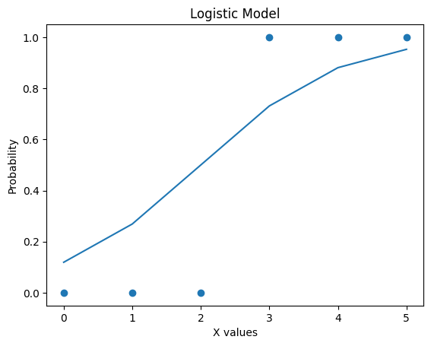

Result:
Thus, the Simple Linear Regression model was successfully implemented using the Least Squares Method.

